NGPF Case Study

Insurance

Case Study Summary  Description: In this Case Study, students will play the role of a new insurance claims representative who helps various clients deal with different aspects of using their auto insurance.  Internet Usage: Required  Spreadsheet Skills: None |  | Alignment to Insurance Unit Learning Objectives:  Students will be able to  - Explain the fundamental ways that insurance companies provide coverage but also make money as a business (11.1)  - Identify steps to take immediately after an auto accident and successfully file a claim (11.4)

Fender Bender Frenzy!
Jamal is new to the T-Wrecks Insurance Company team as an insurance claims representative and is excited to help folks out with their car insurance needs! This is his second week at this position and he is learning the ropes to provide high quality service to T-Wrecks clients.

One of Jamal’s first projects is to create a page for the T-Wrecks company website on auto insurance that walks clients through the steps they should take after they get into a car accident. Here’s what he has so far:

Car accidents themselves can’t be anticipated, but you can be prepared. The time immediately following a car accident is crucial to filing a successful car insurance claim, so knowing the steps will be incredibly helpful in that process.

Jamal conducts some online research to review what people should have with them in the case they get into accident and what they should do during and after an accident.

Answer This:

- Search the internet to find some online resources that provide details on what to do to PREPARE for a car accident, what to do IMMEDIATELY after the accident, and FOLLOW-UP tasks afterwards. Fill in the table below using the information you gathered online to help Jamal create content for the T-Wreck’s website.

BEFORE | DURING | AFTER
How to prepare for an accident | What to do immediately after an accident | Follow-up tasks afterwards

With your help, Jamal is now finished with the website page and submits it to his manager for review. His manager says, “This looks great! This will help many folks better understand what needs to be done at each stage after a car accident. Thank you! I’m about to hop into a meeting, but I’ve got another project for you later.” Jamal heads back to his desk when the phone rings…

Jamal: Good morning, this is Jamal with T-Wrecks Insurance Company. How can I help you today?

Stephanie: Hi Jamal, this is Stephanie Salas. On the way to work this morning, I was slowing down to match the pace of traffic and someone rear-ended me! Both of our cars have damage! I am safe now at work, but wanted to follow up with T-Wrecks about what to do next regarding filing an auto insurance claim.

Jamal: I’m so sorry to hear about the accident, but glad that you are now safe! Do you have the police report and pictures of the damage?

Stephanie: Yes, I have both!

Jamal: Excellent. Let’s get started on collecting and organizing all of the necessary information to make the claims process as smooth as possible. I can email you a Claims Worksheet that you will need to complete.

Stephanie: That sounds fantastic. Thank you so much! This is my first car accident and first time filing an auto insurance claim.

Jamal: You did the right thing and called us as soon as you got to a safe area! I’m going to send you an email with a claim number and some tips on filling out an auto insurance claim. Once you are done, we can reconnect to talk about next steps.
Stephanie: Thanks! I’ll give you a call back in about an hour when I’m all done with the claims worksheet.

Jamal: Sounds good!

Exhibit 1: Email from Jamal
To: | Stephanie Salas
From: | Jamal Turner
Subject: | T-Wrecks Insurance Claim #: 716550
Ms. Salas,

Thank you for contacting me regarding your recent automobile incident. I’ve opened a claim on your behalf. Your claim number is 716550.

As you gather information about the accident, please record it on the Claims Worksheet attached below. Additionally, here are some tips on filling out an auto insurance claim:

Best,
Jamal

Answer This:

- Jamal does some online research and skims through this helpful Wallethub article. What are 3 important tips on filing an auto insurance claim that Jamal should include in his email to Stephanie?

Exhibit 2: Police Report
Mississippi State Highway Patrol
1900 W George Washington Ave, Jackson, MS 39216
(601) 841-5019
Police Accident Report
Police Report #: 729A24PF |  | State Motor Vehicle Report #: 12407923
Date: 4/12/2019 | Time: 8:00 a.m. | Location: I-55, 37 mi. north of Jackson
Party #1 Involved
Name: Stephanie Salas |  | Age: 19
Address: 111 Poplar Lane. Jackson, MS 39216 |  | Phone Number: (601) 992-0019
Make: Ford | Model: Explorer | Year: 2003 | License Plate: 63A0BW
Party #2 Involved
Name: Lawrence Stanley |  | Age: 31
Address: 37 Durant Circle  Canton, MS 39046 |  | Phone Number: (601) 712-0331
Make: Honda | Model: Civic | Year: 1999 | License Plate: Y78PB4
Witness(es)
Name: Monse Finnie |  | Phone Number: (601) 665-9041

Accident Report
At approximately 8:00 a.m. on Friday, April 12, 2019, Stephanie Salas (age 19) was driving her 2003 Ford Explorer XLT southbound on Interstate 55, approximately 37 miles north of Jackson. Her speed was approximately 55 miles per hour.

At this time, Lawrence Stanley (age 31), was travelling behind Ms. Salas in his 1999 Honda Civic at a distance of approximately 100 feet, at a speed of approximately 60 miles per hour. Ms. Salas then slowed her speed while Mr. Stanley did not, and a collision occurred.

Ms. Salas immediately telephoned 911. I received the dispatch call at 8:04 a.m. and arrived on the scene at 8:11 a.m. Ms. Salas and Mr. Stanley had moved over to the side of the road and were exchanging insurance information. Another motorist, Monse Finnie (age 29) also pulled over, having claimed to witness the accident.

Mr. Stanley alleges that Ms. Salas slowed abruptly, and he was unable to decrease his speed enough to avoid a collision. Ms. Salas says she slowed at the same pace as the rest of traffic. Ms. Finnie said traffic slowed at a “normal speed,” and said she noticed Mr. Stanley’s eyes looking down in his vehicle, and he appeared to be using a cellular telephone. Mr. Stanley denied this claim.

Ms. Salas and Mr. Stanley both sustained only minor scratches. Airbags deployed in both vehicles. Ms. Salas’ vehicle sustained major damage to the rear of the vehicle, while Mr. Stanley’s vehicle sustained significant damage to the front bumper and hood.

Upon taking statements from all parties, and ensuring no medical attention was needed, I deemed there were no imminent health or criminal requirements and departed the scene once tow trucks arrived to take both vehicles to repair shops for inspection.

Signature
Officer Name: James Moore |  | Signature:  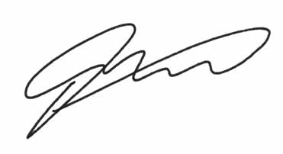
Badge #: 550192 | Date: 4/12/2019
NOTE: This is NOT AN OFFICIAL POLICE DOCUMENT. It has been created specifically for this activity and is 100% fictional. Any information below is only intended for the educational purpose of preparing students in the event of a car accident. Besides the logo, all information about the Mississippi Highway Patrol has been changed. Please do not contact MHP in regards to this document.

Exhibit 3: Photographs

Stephanie Salas’ 2003 Ford Explorer
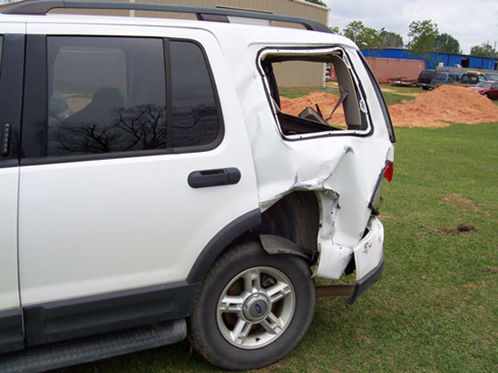 | 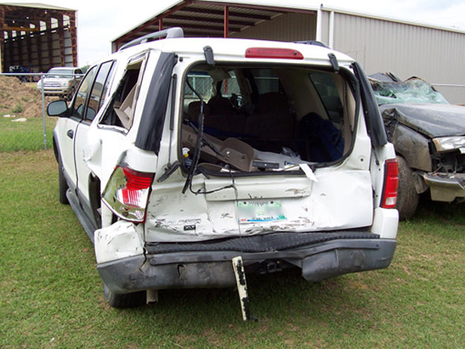

Lawrence Stanley’s 1999 Honda Civic
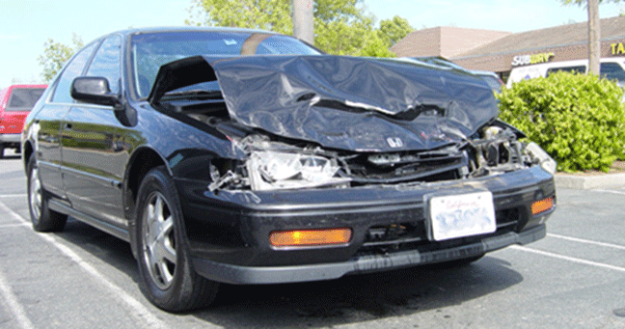

Exhibit 4: Insurance Cards

Stephanie Salas’s Insurance Card

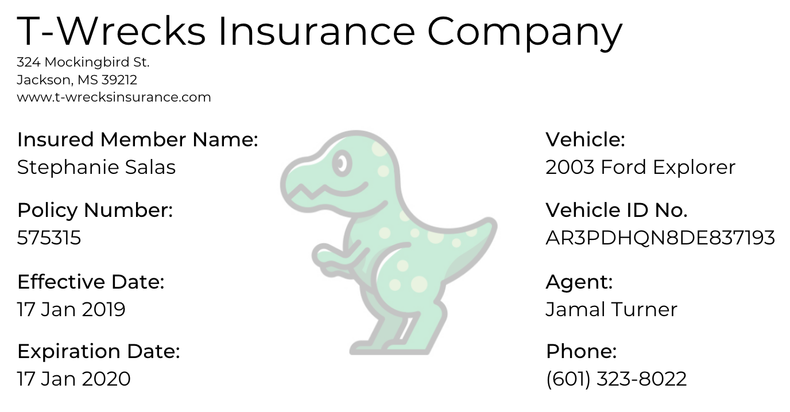

Lawrence Stanley’s Insurance Card

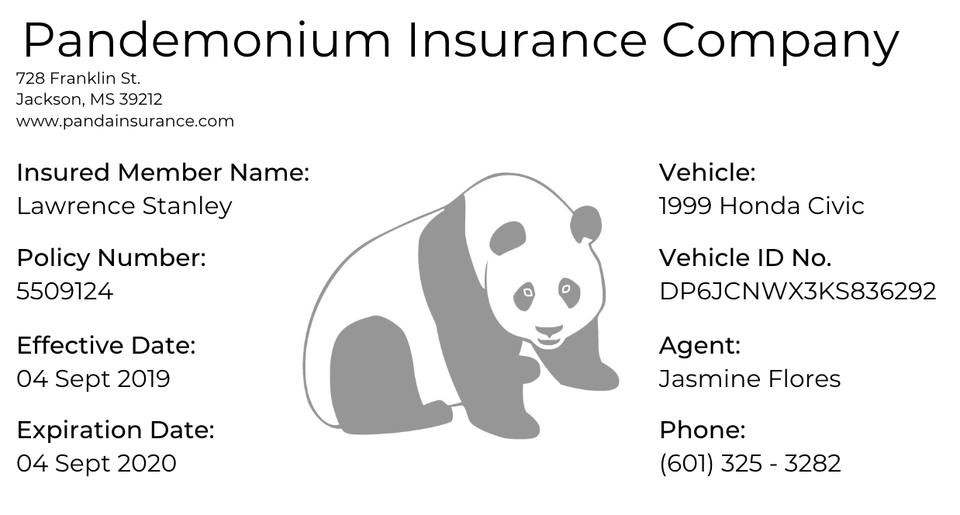

Answer This:
- Using Exhibits 1 - 4, help Stephanie fill out the Auto Insurance Claims Worksheet.

T-Wrecks Insurance Company
CLAIMS WORKSHEET
CLAIM NUMBER:

Accident/Loss Info
Date: | Time: | Location:

Who Else Was Involved?
Name of Other Driver:
Phone Number: | Address:
Other Driver’s Insurance Company:
Phone Number: | Address:
Name of Other Passenger: | Phone Number:
Name of Other Passenger: | Phone Number:

Your Claims Rep
Name: | Phone Number:

Your Accident/Loss
Police Report Number:

State Motor Vehicle Report Number:

Local Police Station Phone Number:
Briefly Describe the Accident and Damage:

While Stephanie is filling out the claims worksheet at her workplace, back at the T-Wrecks Insurance office, Jamal’s manager swings by his desk and says, “Here’s that next project I mentioned earlier! We have a few folks whose cases we've reviewed and unfortunately, we have to deny their claims. I just sent you their files. Please contact them back explaining why their claim was denied and provide them with some precautions that they can take in the future to make sure that their claim goes through next time.”

Jamal double checks this list of reasons why car insurance claims can be denied and then checks his email, seeing 2 different files from his manager. The first customer called in two months after his car accident and reported that he is suffering from whiplash. He would now like to add this information to his insurance claim.

Answer This:

- What reasoning should Jamal provide for why this car insurance claim was denied?

- What advice can Jamal give this client to improve his chances of getting approved for a similar claim in the future?

The second file is from a customer who was on a road trip and had a thief break into her car through her back window. She says that she thought she had comprehensive coverage, but in reality, her coverage did NOT include it.

Answer This:

- What reasoning should Jamal provide for why this car insurance claim was denied?

- What advice can Jamal give this client to improve his chances of getting approved for a similar claim in the future?

- What are 3 other common reasons that car insurance claims can be denied that you want to make sure YOU are aware of for yourself?

Jamal reflects on these two clients’ situations and doesn’t want the same thing to happen to Stephanie, so he brainstorms some advice that he can give her when they reconnect. After Jamal clicks “send” on the email to the last client, a new message arrives in his inbox and it’s Stephanie’s Claim Worksheet. He takes a few moments to review it and all of the information needed is included. As Jamal organizes the files into her profile, his phone rings once more...

Stephanie: Hi Jamal, I finished the claims worksheet and just sent it your way.

Jamal: Yes, I have just taken a look at it and you’ve included every detail that we need!

Stephanie: Great! I had a stellar friend help me out to make sure I didn’t miss anything.

Jamal: Looks good. Now we at T-Wrecks Insurance will continue to review and process this claim, determine what will be covered, and assess the loss and damage. We will reach out if we need additional information and keep you updated on the status.

Stephanie: Thanks Jamal! Is there anything that I can do on my end to ensure that my claim gets approved?

Answer This:

- What advice can Jamal give Stephanie to make sure that her claim gets approved?

Stephanie: Great advice...I’ll be sure to do so.

Jamal: You got it. Thank you for being a client with T-Wrecks Insurance and for being so proactive on getting this resolved as soon as possible!

Stephanie: Thank you so much for your help. Have a great day!

And with that last phone call, Jamal checks off his final big task on his to-do list for the day. He forwards all of Stephanie’s information to his T-Wrecks Insurance adjuster colleague and packs up to go home.

Answer This:

- After assisting Jamal at the T-Wrecks Insurance office and helping Stephanie with her claims worksheet, what are 3 things you want to keep in mind if you get into a fender bender accident? Explain why each of these aspects are important to the auto insurance claim process.

