NGPF Activity Bank
Managing Credit

Spanish Version
Teacher Tip Video

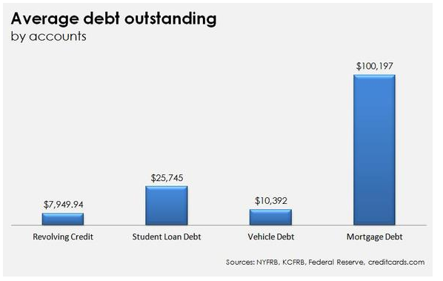
CALCULATE: High Rate v. Debt Snowball
According to a Motley Fool article from 2015, this graph shows the Average Debt Outstanding for Americans who hold debt.

Let’s assume you’re the “average American” holding this debt and see what your options look like using the High Rate method of debt repayment in comparison to the Debt Snowball Method.

Assume you’ve got $1400 each month to contribute toward your debts. Assume you’re living a cash lifestyle from now on and not adding to any of these balances.

Here’s a snapshot of your monthly debt obligations:

Debt Type | Amount | Interest Rate | Monthly Payment
Credit Card 1 | $5000 | 26.9% | 3% of balance
Credit Card 2 | $2950 | 8.25% | 3% of balance
(Private) Student Loan Debt | $25,745 | 10.5% | $347
Vehicle Debt | $10,392 | 4.61% | $310
Mortgage Debt | $100,197 | 3.44% | $447

Part 1 - High Rate
Enter your 5 debts into the What’s The Cost? Calculator, using “Interest Order” (aka High Rate Method) and $1400 on servicing your debts, and answer these questions:

- How long does it take to pay off this debt?

- How much total interest do you pay on your debts?

- List the debts in which order they are paid off:

- At the end of 3 years, how many of the original 5 debts do you have remaining?

- A standard repayment term for a student loan is typically 10 years, or 120 months. How long does it take you to repay your student loan using this method?

- A standard repayment term for a home loan is 30 years, or 360 months. How long does it take you to repay your mortgage using this method?

- Why are your student loan and home loan paid more quickly using this method than if you had followed their standard repayment plan?

Following advice on how to pay down debt more quickly, you cut out unnecessary spending in your budget, and you pick up a side job that generates an extra $200 per week or $800 per month. Now, instead of paying $1400 toward your debts per month, you’re paying $2200.

- How long does it take to repay your debt now?

- How much total interest do you pay on your debts?

Part 2 - Debt Snowball
At the top of the What’s The Cost? Calculator, switch to “Balance Order” (aka Debt Snowball Method) and $1400 on servicing your debts, and answer these questions:

- How long does it take to pay off this debt?

- How much total interest do you pay on your debts?

- List the debts in which order they are paid off:

- How long does it take to pay off the lowest balance credit card, with a balance of $2950?

- If the whole point of Debt Snowball is to pay off your smallest debt first, why not devote the full $1400 each month toward that credit card, and pay it off in 3 months?

- At the end of 3 years, how many of the original 5 debts do you have remaining?

Just like before, you make changes to your lifestyle and now, instead of paying $1400 toward your debts per month, you’re paying $2200.

- How long does it take to repay your debt now?

- How much total interest do you pay on your debts?

Part 3 - Comparison
- Complete the following chart:

 | Paying $1400 per Month |  | Paying $2200 per Month
 | # of Months | Total Interest Paid | # of Months | Total Interest Paid
High Rate
Debt Snowball

- What is an advantage to using the High Rate method?

- What is an advantage to using the Debt Snowball method?

- A friend says, “The most important thing you can do, to minimize your debt quickly, is use the High Rate Method.” Do you agree or disagree? Explain your answer.

