Brian Tracy's Steps in a Sales Cycle

The Step by Step Approach to Success By Thomas Phelps
Updated April 28, 2017
One short cut to success in life or in any industry is to follow in the footsteps of those who earned success before you. This is especially true when it comes to the sales industry. These 7 steps that should be included in every sales cycle, also track very well for those searching for a job and completing the interviewing process.

Step 1 - Prospecting

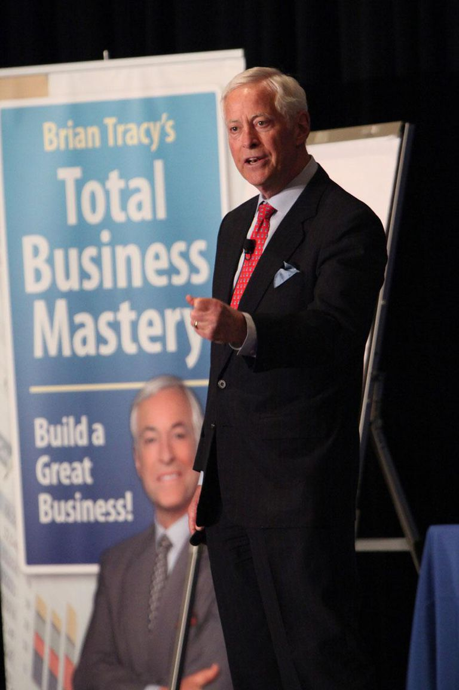
If you don't have people to sell to, you really have nothing to sell. Everything starts with Prospecting, which is essentially the process in which you separate suspects from prospects. Prospecting takes on many forms. Some sales professionals focus on door to door cold calling, while others rely on networking or direct mail campaigns.
No matter how you prospect and no matter whether you love prospecting or hate it, every sales cycle begins with here.

Step 2 - Building Rapport

A simple handshake is like a standing ovation to a sales professional. If people trust you, they will find a way to do business with you. If people don't trust you, however, they will find a reason not to buy from you. Once you've found some prospects, you need to shift your focus your attention on building trust and rapport. If you don't do well in this step, you will really struggle through every other step. A common mistake many in sales make is trying too hard to be liked. Remember, in life and in sales, it is more important to be respected and trusted than it is to be liked.

Step 3 - Identifying Needs
Funny thing about sales: They are only made to people who have a want or a need that your product or service can fill or solve. The more needs you can identify that can be filled by your product, the better off your chances of closing the sale will be. Some needs are obvious and some take some work to uncover. But once you've uncovered a need and your prospect agrees that the need needs to be filled, you'd better be sure your product can deliver.

Step 4 - Delivering Persuasive Presentations

Many sales people love the spotlight. Being the center of attention with a chance to display their skills are a main reason some get into sales. Despite whether you are a spotlight-fan or are a bit more reserved, you need to be able to effectively present your ideas/solutions/company in a manner that is persuasive, professional and targeted. No matter what form your presentation takes, being prepared and having clear objectives are two of the most important parts of an effective presentation.

Step 5 - Overcoming Objections

99% of your sales cycle will be filled with customer objections. Objections separate the men from the boys, the girls from the woman and the professionals from the actors. If you can learn to not only expect objections but to anticipate and plan for them, they will lose the sting they once had.

The most dangerous objection is the one you never hear your customer state. Surprises may be good on your birthday but they are deal killers during a sales cycle.

Step 6 - Closing the Sales

While most non-sales professionals think that closing is the only thing that sales professional do, closing is just one step in what is often a very long sales cycle. While it may be the most important step, successful closes are built by completing each of the previous steps and not by jumping right to asking for the sale.

There are hundreds of closing techniques, tips, and tricks, but the most important thing to remember is that closing a sale is not a stand-alone event but just a step in a process.

7

Step 7 - Getting Repeat Sales and Referrals
The final step in a sales cycle is really the first step in your next sales cycle. Asking for referrals from your customers is, for some reason, something that most sales professionals do not do. While there are many excuses that people give to explain why they don't ask for referrals, there are no good reasons why you shouldn't ask for referrals.
If you can't get referrals for whatever reason, you should at least ask your customer if you can use them as a reference. Having references for your prospects to call on makes building trust much easier. And having a fresh supply of referrals makes prospecting much easier and more productive.

